LAPORAN RESMI
GRAFIKA KOMPUTER

PERTEMUAN III
MEWARNAI OBJECT



NIM : 21104410012
NAMA : Cheryl Rio Kurnia putra
JURUSAN : Teknik Informatika
KELAS : TI 4A

JURUSAN TEKNIK INFORMATIKA
FAKULTAS TEKNOLOGI INFORMASI
UNIVERSITAS ISLAM BALITAR
2023

LEMBAR PERSETUJUAN

PERTEMUAN III
MEWARNAI OBJECT

NIM : 21104410012
NAMA : Cheryl Rio Kurnia putra
JURUSAN : Teknik Informatika
KELAS : TI 4A

Disetujui,
Blitar, … mei 2023
Dosen

Mohammad Faried Rahmat, S.ST., M.Tr.T
NIDN.

Contoh Mewarnai Object
- Praktek 1 - Background
function setup() {
createCanvas(200, 200);
}
function draw() {
background(0);
}

Output :


- Praktek 2 - Background RGB
function setup() {
createCanvas(200, 200);
}

function draw() {
background(252, 61, 224);
}

Output :


- Praktek 3 - fill
function setup() {
createCanvas(200, 200);
}
function draw() {
background(220);
fill(255,255,0);
circle(100,100,50);
}

Output :
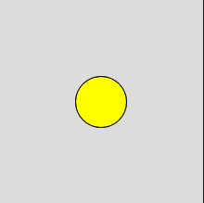

- Praktek 4 – fill beberapa object
function setup() {
createCanvas(200, 200);
}

function draw() {
background(220);
fill(255, 255, 0);
circle(100, 100, 50);
rect(0, 0, 100, 50);
ellipse(50, 70, 30, 30);
}

Output :
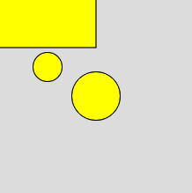

- Praktek 5 – No fill
function setup() {
createCanvas(200, 200);
}

function draw() {
background(220);
fill(255, 255, 0);
circle(100, 100, 50);
rect(0, 0, 100, 50);
noFill();
ellipse(50, 70, 30, 30);
}

Output :
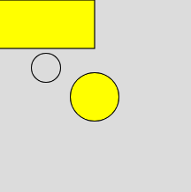

- Praktek 6 – No fill - Transparan
function setup() {
createCanvas(200, 200);
}

function draw() {
background(220);
fill(255, 255, 0, 50);
circle(100, 100, 50);
rect(0, 0, 100, 50);
noFill();
ellipse(50, 70, 30, 30);
}

Output :

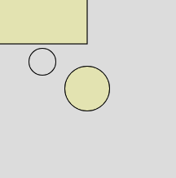

Ubah Ukuran Garis Warna
function setup() {
createCanvas(200, 200);
}

function draw() {
background(220);
fill(255, 255, 0, 50);

// Ukuran Garis
strokeWeight(8);

// Garis Hijau
stroke(0, 255, 0);
circle(100, 100, 50);

// Garis Merah
stroke(255, 0, 0);
rect(0, 0, 100, 50);

noFill();

// Garis Biru
stroke(0, 0, 255);
ellipse(50, 70, 30, 30);

// Tanpa Garis
noStroke();
fill(255, 255, 0);
circle(20, 180, 50);
}

Output :
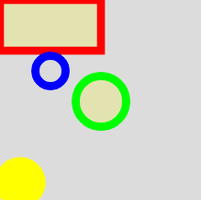

Contoh Kasus Pewarnaan Beberapa Object
function setup() {
createCanvas(800, 420);
}

function draw() {
background('#ffffff');

strokeWeight(1);

// Objek Coklat
fill('#845542');
square(10,10,230);

// Objek Ungu
fill(58, 18, 94);
triangle(260,10,260,240,490,125);
fill(58,18,94,100);
circle(375,125,230);

// Objek Pelangi
noStroke();
// Merah
fill('#d41a13');
rect(10,260,480,20);
// Jingga
fill('#eb6222');
rect(10,280,480,20);
// Kuning
fill('#fff000');
rect(10,300,480,20);
// Hijau
fill('#0ea21f');
rect(10,320,480,20);
// Biru
fill('#0f1cff');
rect(10,340,480,20);
// Nila
fill('#490083');
rect(10,360,480,20);
// Ungu
fill('#9400d3');
rect(10,380,480,20);

// Objek Abu Abu
strokeWeight(4);
stroke('#000000');
fill('#aaaaaa');
ellipse(650,210,280,400);
}

Output :
